**Hasbrouck Heights Public Schools**

**Genesis Parent Access Instructions**

**Technology Assistance (201) 639-6911 call and leave a message**

# Introduction

The Genesis Parents Module is a safe, secure way to view your child's school record for the current school year. If your school district chooses, you may have access to the following information:

Your child or children’s:

* Grades
* Report Cards
* Daily Attendance Record
* Teacher Gradebook assignments and assignment grades
* Back to School Forms
* Other notifications

# Logging in

[Hasbrouck Height Genesis Parent Portal](https://parents.genesisedu.com/hasbrouckheights/parents?gohome=true)

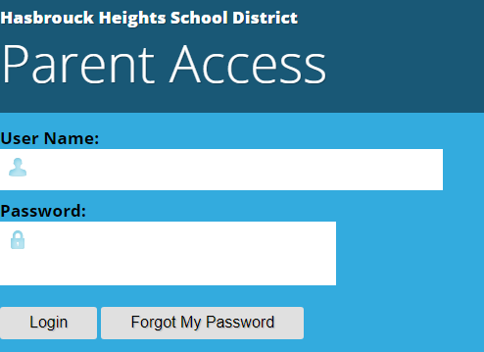

1. Enter your email address (lower case) in the “User Name” field.
2. Enter your password in the “Password” field. If you did not receive a temporary password, you may request one by clicking the ‘Forgot My Password” link.
3. Click “Login”

# Getting Started

***Your "HOME" Screen - The Student Dashboard***

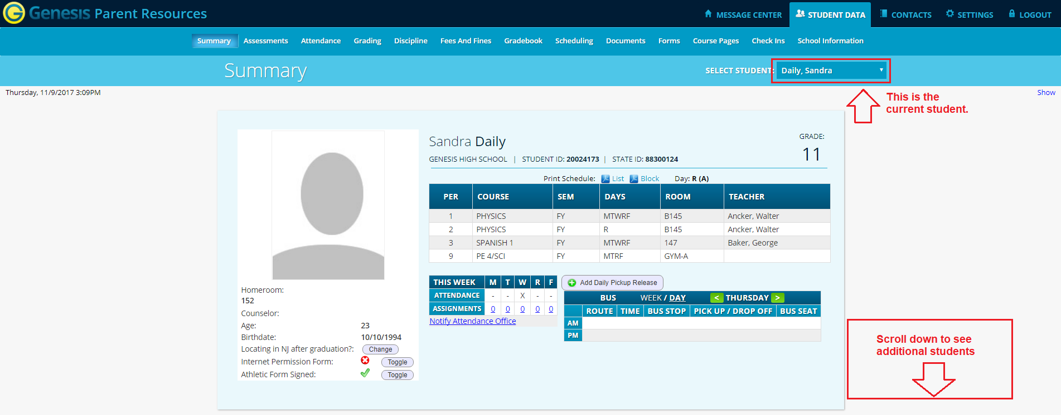

**Genesis Parent Access Student Data Summary – Student Dashboard Screen**

When you login to Genesis Web Access the first screen you see is your student’s Student Data Summary. This is the student’s Dashboard screen. You will see a ‘dashboard’ for every student linked to your login. All your students will be on one screen.

**Selecting a Student**

If you have more than one child in the school, you can choose “who” you see via the dropdown. All children will be listed on the home screen. You may need to scroll down to see the schedule you want.

The name of the 'currently selected student' will be displayed in the 'Select Student' drop down at the top of the screen. To pick a different student, click the Select Student drop down and choose the name of the student you want to select. Once you have done that, the tabs will take you to the newly selected student's information.

## The "Select Student" Drop Down

This drop down contains the names of all the students that you have access to. If you are missing a student, please contact your school or district office.

**More Information About Each Student**

The ‘Summary’ screen has a dashboard for each of your students. The other light blue tabs give you more information about one student at a time.

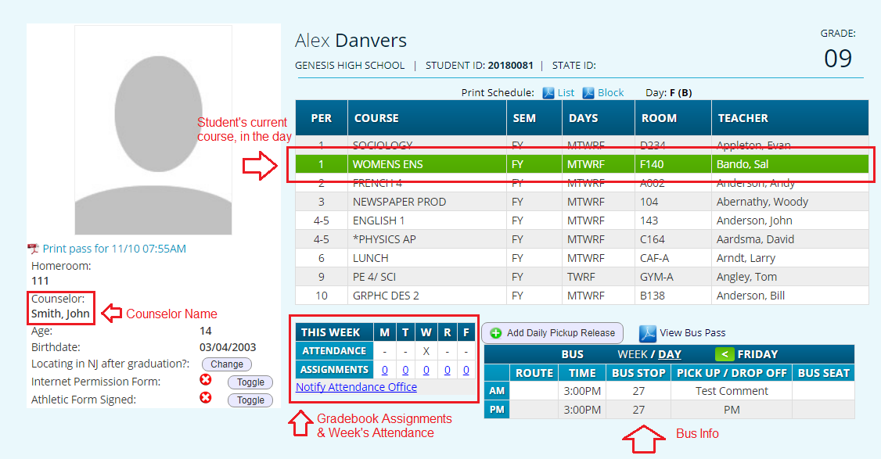

If your high school or middle school student has a class schedule, click one of the  icons to get a printable copy of the schedule. It can be had in either list or block form.

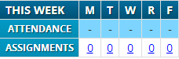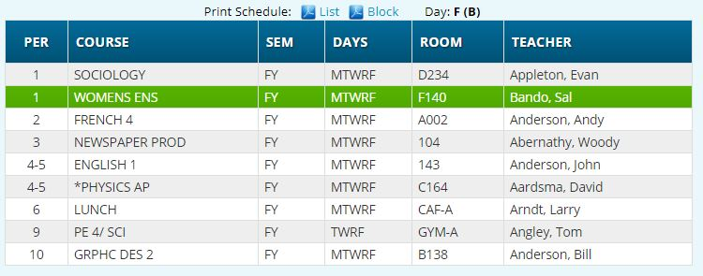

**You can also see their current location in the “Schedule” panel.**

## Attendance

Daily Attendance or Class Attendance is displayed for your child. Hasbrouck Heights High School takes attendance in each class. The middle schools take daily attendance. The legend for the color codes describes the potential reasons for the absence from school.

If your child is absent from school on any given day, that day will be represented in one of the colors found in the legend. By moving your cursor over that day, a sub‐menu will appear giving you additional information on that absence.

# Attendance

## *Daily Attendance*

Daily Attendance is your child’s official daily attendance.

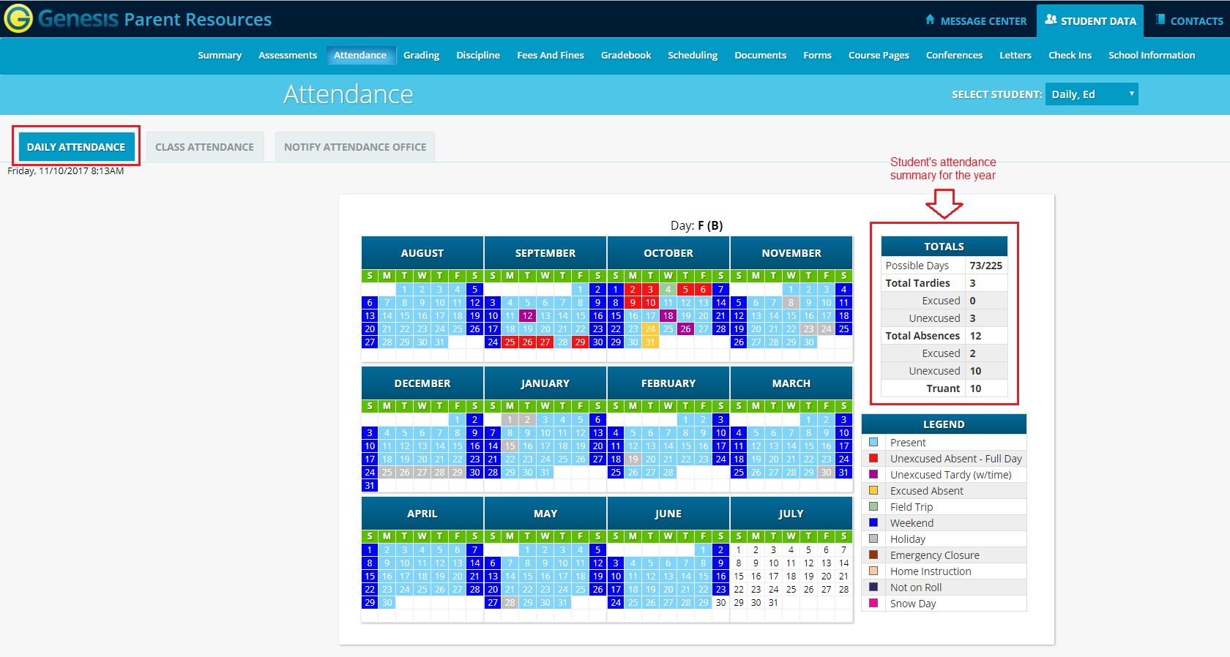

This is your student’s Daily Attendance summary for the whole school year.

* The Attendance Calendar with each day color coded
* A summary of the student’s Attendance for the year
* The ‘Legend’ of Attendance codes for your school district.

## *Class Attendance*

If your child is in Middle School or High School and has separate courses, Class Attendance may show you their attendance for each separate subject. You must click the  tab under G-6 to find class attendance. If this button does not appear, your child’s school does not record individual class attendance.

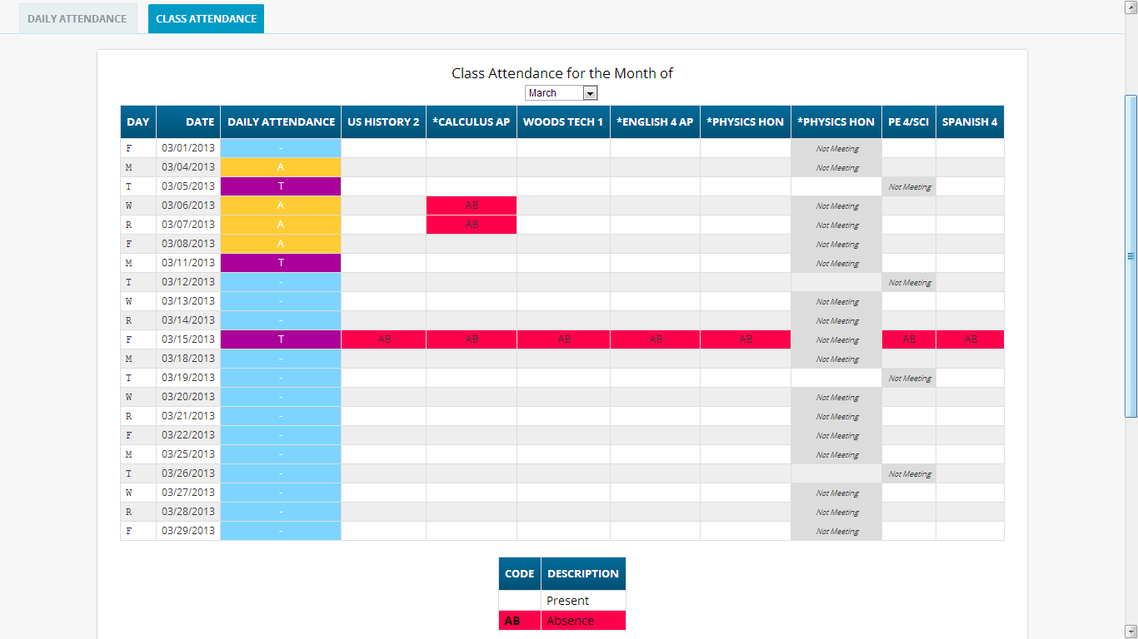

To see Class Attendance, click the  tab.

Scroll down to see students Class Attendance totals

# Grading

**Current Year Report Card Grades & Current Report Card**

The Grading screen gives you access to your student’s Marking Period grades and teacher comments and possibly the student’s most recent actual report card.

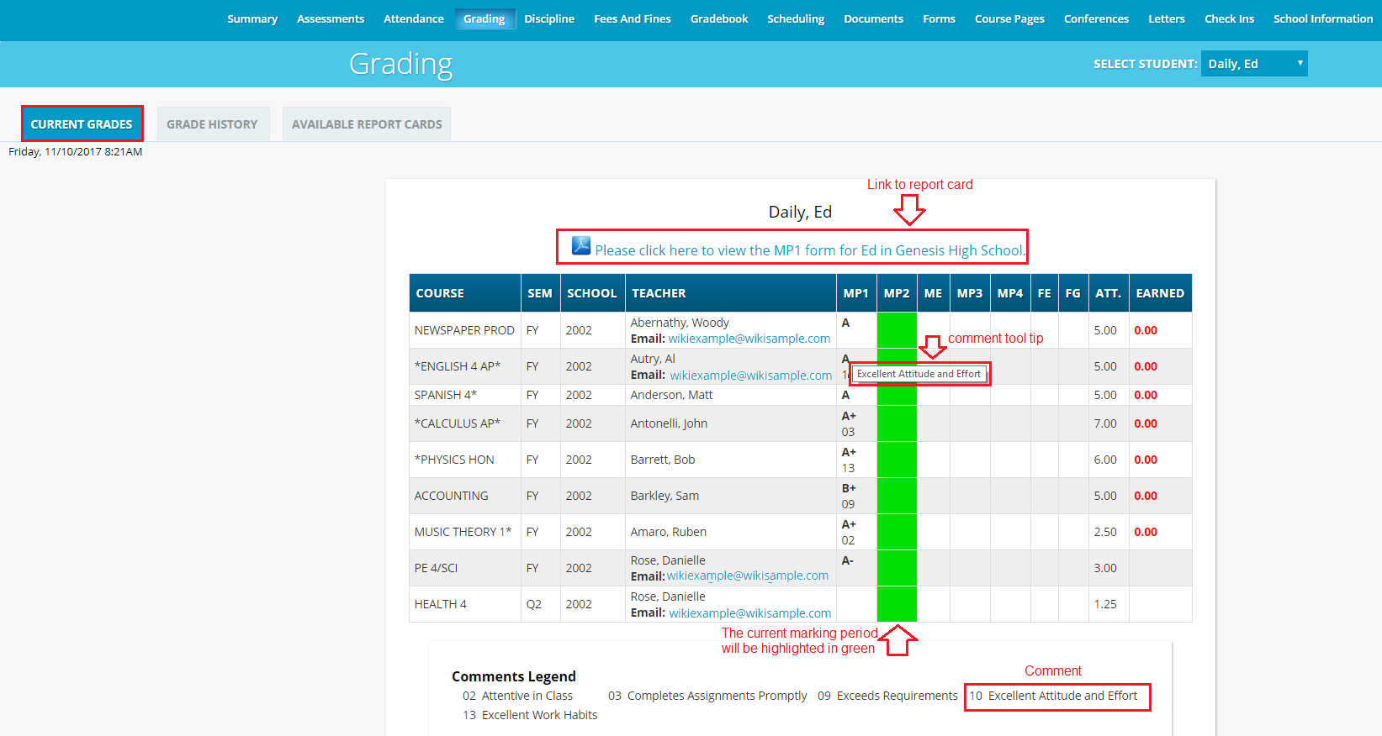

The Student’s Grading screen contains lots of information and a link to their current report card. The numbers below each grade are the comments the student has received for the Marking Period.

Place your cursor on a comment number and the corresponding text is highlighted in yellow – the text of the comment is also displayed in a Tool Tip. A link to the current report card is at the top of the screen and links to email teachers may appear below the teacher’s name.

**The Grading Screen**

This screen summarizes your student’s Report Card grades for the current year.

The current Marking Period is highlighted in green.

Each box shows the grade and comment codes that your student has received in the corresponding class for the selected Marking Period. If you place your cursor on a comment code, the corresponding comment will be highlighted (e.g. ). In addition, the text of the comment will appear in a tooltip (e.g. ).

In addition, as outlined below, you can access and view your student’s most recent report card.

**Viewing your Child’s Current or Most Recent Report Card**

If you are able to view your child’s actual report card, a G-8 message will appear between your child’s name and their list of grades:

If this message appears, click it to view the actual report card displayed in Adobe Reader (Adobe Reader must be installed on your computer). A sample report card is shown below.

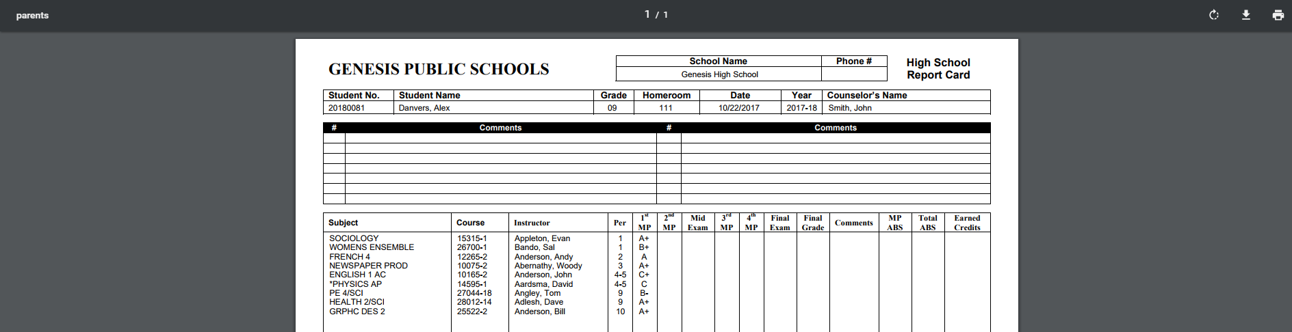

# Gradebook

## *Weekly Summary of Assignments Screen and Marking Period Averages*

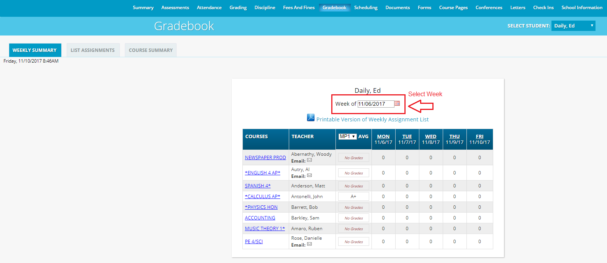

The Gradebook Summary Screen – Click on the highlighted course name to see all the Assignments for that course. Click on a teacher’s email address to send email to that teacher.